**SESHADRI RAO GUDLAVALLERU ENGINEERING COLLEGE**

(An Autonomous Institute with Permanent Affiliation to JNTUK, Kakinada)

SeshadriRao Knowledge Village, Gudlavalleru

**III B.Tech II Semester (R20) First Descriptive Examination**

**Image Processing**

**Key**

1. **a) Summarize the fundamental steps involved in Digital Image Processing. (3M)**

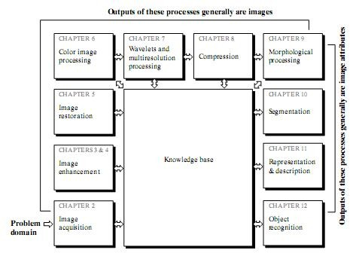Image acquisition is the first process shown in figure. The acquisition could be as simple as being given an image that is already in digital form. Generally, the image acquisition stage involves preprocessing, such as scaling. Image enhancement to bring out detail that is obscured, or simply to highlight certain features of interest in an image. It is important to keep in mind that enhancement is a very subjective area of image processing, image restoration is objective, in the sense that restoration techniques tend to be based on mathematical or probabilistic models of image degradation.

Color image processing is an area that has been gaining in importance because of the significant increase in the use of digital images over the Internet. Wavelets are the foundation for representing images in various degrees of resolution. Compression, as the na me implies, deals with techniques for reducing the storage required to save an image, or the bandwidth required to transmit it. Morphological processing deals with tools for extracting image components that are useful in the representation and description of shape. Segmentation procedures partition an image into its constituent parts or objects. In general, autonomous segmentation is one of the most difficult tasks in digital image processing. A rugged segmentation procedure

**b) Discuss the process of Image Acquisition. [CO1; BL2](2M)**

There are 3 principal sensor arrangements (produce an electrical output proportional to light intensity). (i)Single imaging Sensor (ii)Line sensor (iii)Array sensor **(Any two methods – 2M)**

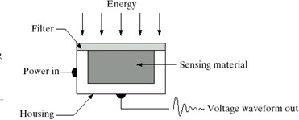

**(i)**



**(ii)**



**(iii)**

**Fig: (i)Single image (ii)Sensor line sensor (iii)Array sensor**

**Image Acquisition using a single sensor**

The most common sensor of this type is the photodiode, which is constructed of silicon materials and whose output voltage waveform is proportional to light. The use of a filter in front of a sensor improves selectivity. For example, a green (pass) filter in front of a light sensor favours light in the green band of the color spectrum. As a consequence, the sensor output will be stronger for green light than for other components in the visible spectrum.

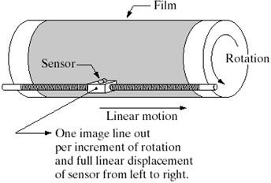

**Fig: Combining a single sensor with motion to generate a 2-D image**

In order to generate a 2-D image using a single sensor, there have to be relative displacements in both the x- and y-directions between the sensor and the area to be imaged. An arrangement used in high precision scanning, where a film negative is mounted onto a drum whose mechanical rotation provides displacement in one dimension. The single sensor is mounted on a lead screw that provides motion in the perpendicular direction. Since mechanical motion can be controlled with high precision, this method is an inexpensive (but slow) way to obtain high-resolution images.

**Image Acquisition using Sensor Strips**

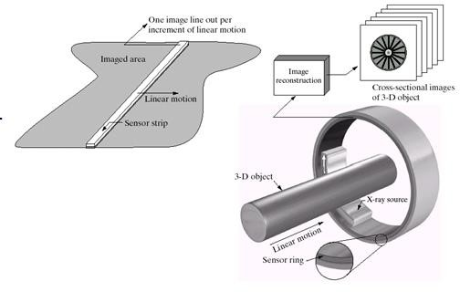

**Fig: (a) Image acquisition using linear sensor strip (b) Image acquisition using circular sensor strip.**

The strip provides imaging elements in one direction. Motion perpendicular to the strip provides imaging in the other direction. This is the type of arrangement used in most flatbed scanners. Sensing devices with 4000 or more in-line sensors are possible. In-line sensors are used routinely in airborne imaging applications, in which the imaging system is mounted on an aircraft that flies at a constant altitude and speed over the geographical area to be imaged.

**Image Acquisition using Sensor Arrays**

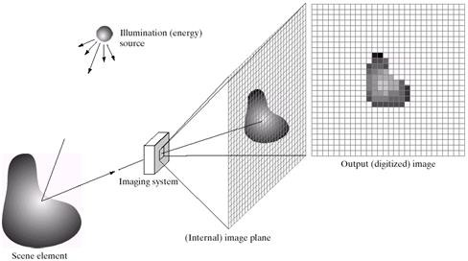

**Fig: An example of the digital image acquisition process (a) energy source (b) An element of a scene (d) Projection of the scene into the image (e) digitized image**

This type of arrangement is found in digital cameras. A typical sensor for these cameras is a CCD array, which can be manufactured with a broad range of sensing properties and can be packaged in rugged arrays of 4000 * 4000 elements or more. CCD sensors are used widely in digital cameras and other light sensing instruments. The response of each sensor is proportional to the integral of the light energy projected onto the surface of the sensor, a property that is used in astronomical and other applications requiring low noise images.

he first function performed by the imaging system is to collect the incoming energy and focus it onto an image plane. If the illumination is light, the front end of the imaging system is a lens, which projects the viewed scene onto the lens focal plane. The sensor array, which is coincident with the focal plane, produces outputs proportional to the integral of the light received at each sensor.

1. **a) Discuss any two point processing methods used in image enhancement. (2M)**
2. linear (negative and identity transformations)
3. logarithmic (log and inverse-log transformations)
4. power-law (nth power and nth root transformations)

**For any 2 Explanation 2 Marks.**

**b) Perform the Histogram Equalization for a given image.**  **[CO2; BL3**]**(3M)**

|  |  |  |  |  |  |  |  |  |  |  |
| --- | --- | --- | --- | --- | --- | --- | --- | --- | --- | --- |
| **Grey level, rk** | **0** | **1** | **2** | **3** | **4** | **5** | **6** | **7** | **8** | **9** |
| **No.of Pixels, nk** | **0** | **0** | **6** | **5** | **4** | **1** | **0** | **0** | **0** | **0** |

**(Procedure-2M, Answer-1M)**

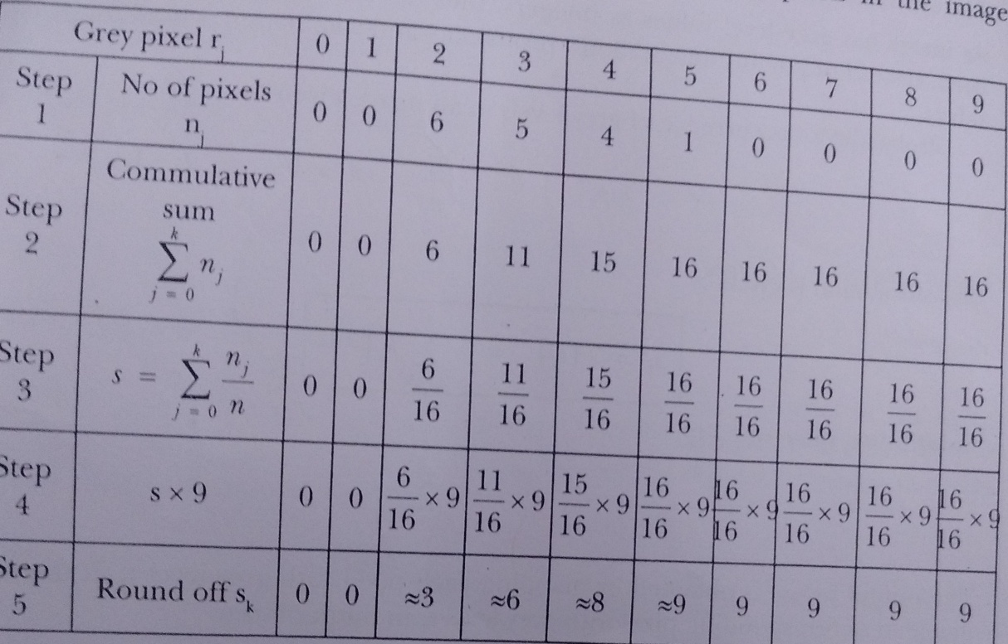

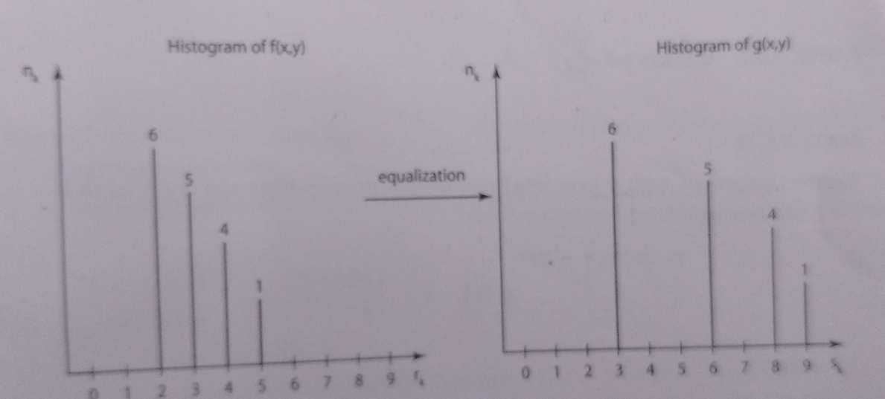

**3.a) Write the conversion formulae for the following: (each conversion 1 Mark)**

**(i) HIS to RGB (ii) CMY to RGB [CO4;BL2](2M)**

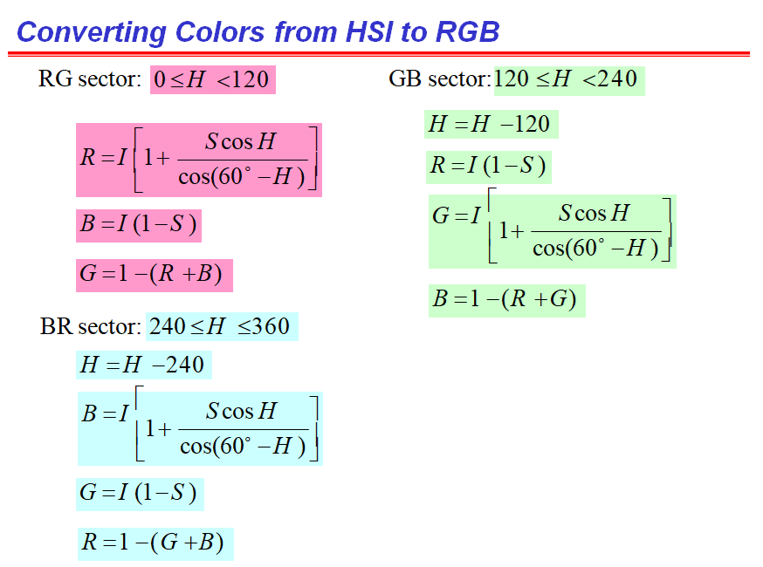

**Converting Colors from CMY to RGB**

**R = 1 - C**

**G = 1 – M**

**B = 1- Y**

**b) How to distinguish one color from another color? [CO4;BL2](3M)**

One color can be distinguished from another color by the following parameters -

1. **Brightness:** the achromatic notion of intensity.
2. **Hue:** the dominant wavelength in a mixture of light waves.
3. **Saturation:** the amount of white light mixed with a hue. Pure colors are fully saturated. Pink (red+white) is less saturated. Hue and saturation are called chromaticity. Therefore any color is characterized by its brightness and chromaticity.

**(Each parameter -1M)**

**Prepared by Mrs.L.Padmalatha**